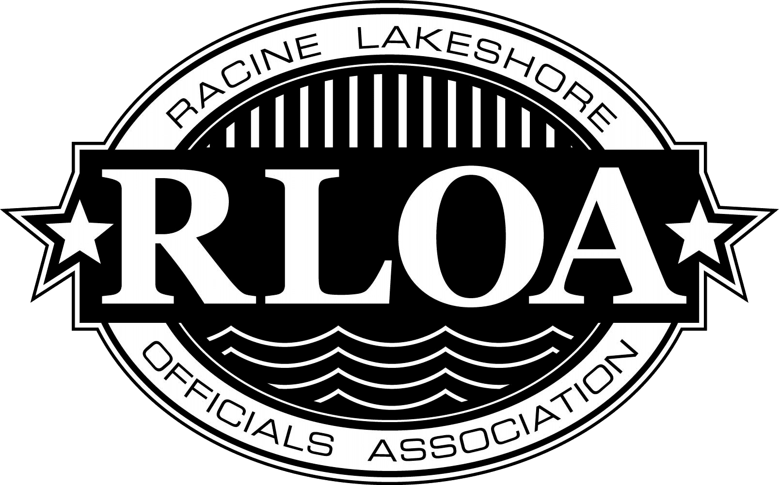
RLOA 2nd Umpire Baseball Clinic will be held on Sunday March 16th, 2025, from 9AM – 5PM at Tremper High School in Kenosha, WI (8560 26th Ave, Kenosha, WI 53143)

AS part of the continuing development training program, this clinic is WIAA approved. By attending the clinic, the WIAA will level you up.
Area of Emphasis: 3 Hour classroom Training, Plate mechanics (Video Taped),
Field Mechanics and Coverage

YOU MUST BE REGISTERED PRIOR TO THE CLINIC DATE

Name: ______________________________________________________
Last First
Address: ____________________________________________________________
Street City ZIP
Cell Phone: _________________________________Umpire Affiliation: ______________________
Email Address: _______________________________________________________
Years Of Umpiring: _______Highest level: __________________Hat Size________ T shirt size_______
WIAA Licensed: Yes/No____________Number: ____________________
Registration and Fee ($75.00 Student $25.00) Due March 14, 2025. Lunch provided. Please arrive from 8-8:45 am to check in. Camp starts at 9AM

Make checks payable to: RLOA
Mail to Scott Trottier 4848-85th Place Kenosha, WI 53142
Online Registration and online payment available at: www.rloa.info
Questions contact Scott Trottier 262-945-1600 email trotts1616@gmail.com
Once Registration & Fee received more info will follow

